Practical-12
Event Management CRUD with Poster Upload and File Validation
Theory
1. Are add, update, and delete functionalities implemented correctly?
Answer: The event-management page demonstrated a successful INSERT of “P12 Tech Workshop 2026” (23 to 24 events) and a successful UPDATE message for the same record. Delete confirmation and completion were reported during the practical, but a separate deletion-success screenshot was not supplied.
2. Is the UI linked with the database correctly?
Answer: Yes. Event counts, event rows, categories, statuses and recent event audit entries were displayed from the StudentHub database. The new test event appeared in the listing, and the update success message was shown.
3. Are poster uploads validated for type and size?
Answer: The TXT upload was rejected with the error “Only JPG, PNG, or WEBP poster images are allowed.” The page specifies a 2 MB upload limit. A valid poster upload was reported as completed, but the available screenshots still show “With Posters: 0”; successful storage and the 2 MB boundary were not independently evidenced.
4. Are success and failure messages displayed?
Answer: Yes. The interface showed green messages after adding and updating an event and a red message after submitting an unsupported file type. A category filter returned five matching Workshop events.
Result:
Practical 12 was used to demonstrate event creation and editing, a database-backed event list, category filtering, feedback messages, invalid poster-type rejection and an event audit trail in StudentHub. The remaining poster, date-correction, status-toggle and deletion outcomes were reported during the practical but were not independently documented by final screenshots.
Evidence of Work (Screenshots)
The original screenshots below document the SQL upgrade, administrator event-management page, successful record operations, file-validation error and event-filter/audit interface. All screenshots are shown without cropping.

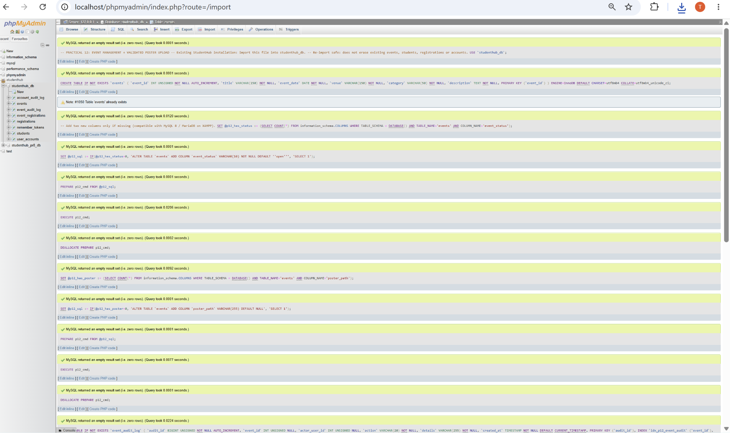
Figure 1: Practical 12 SQL Upgrade Imported into Existing Database
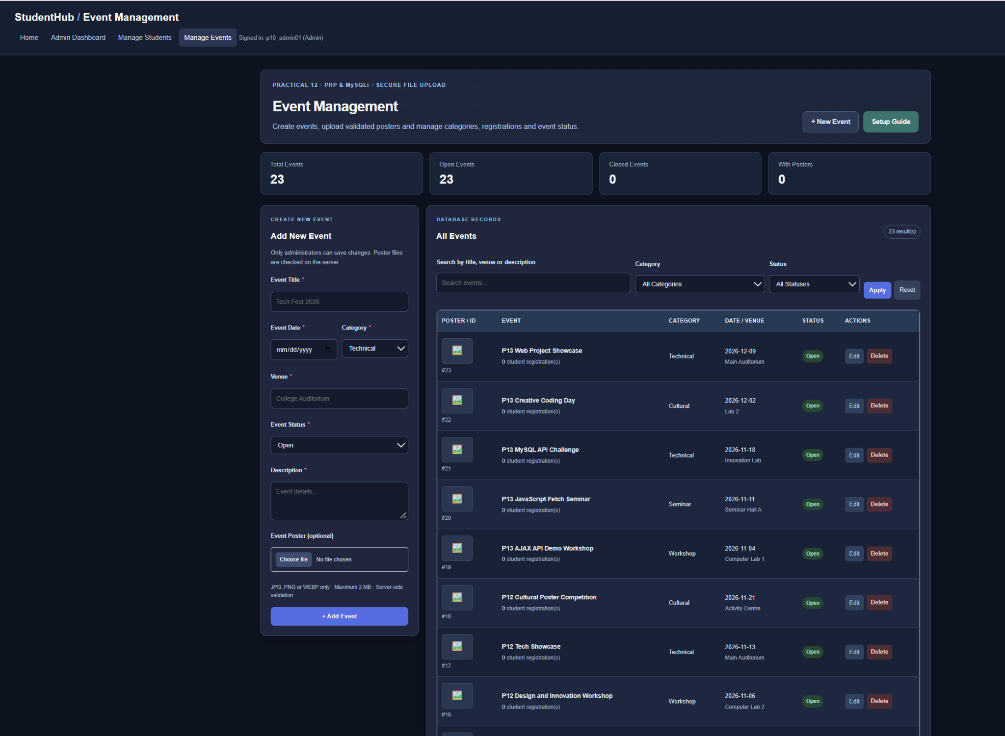
Figure 2: Admin Event Management Dashboard and Poster Upload Form

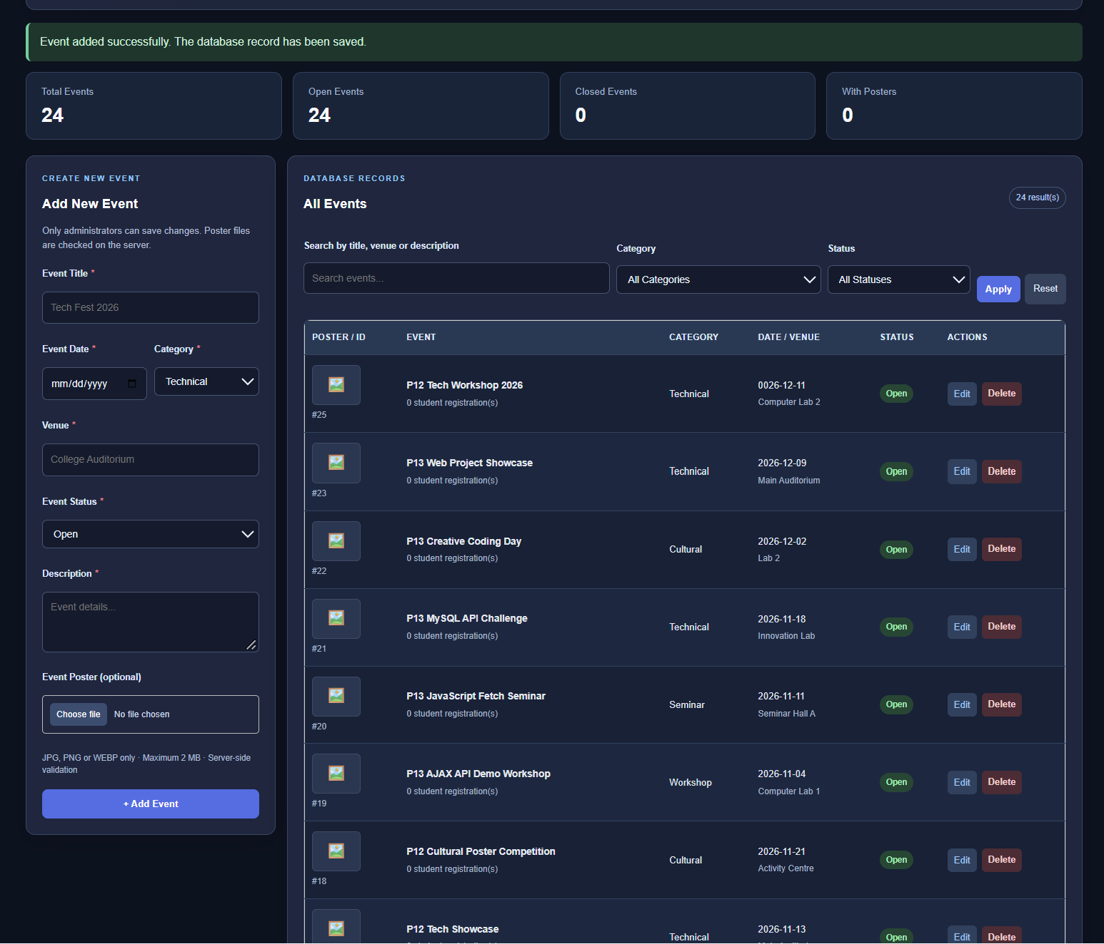
Figure 3: New Event Saved - Total Increased from 23 to 24
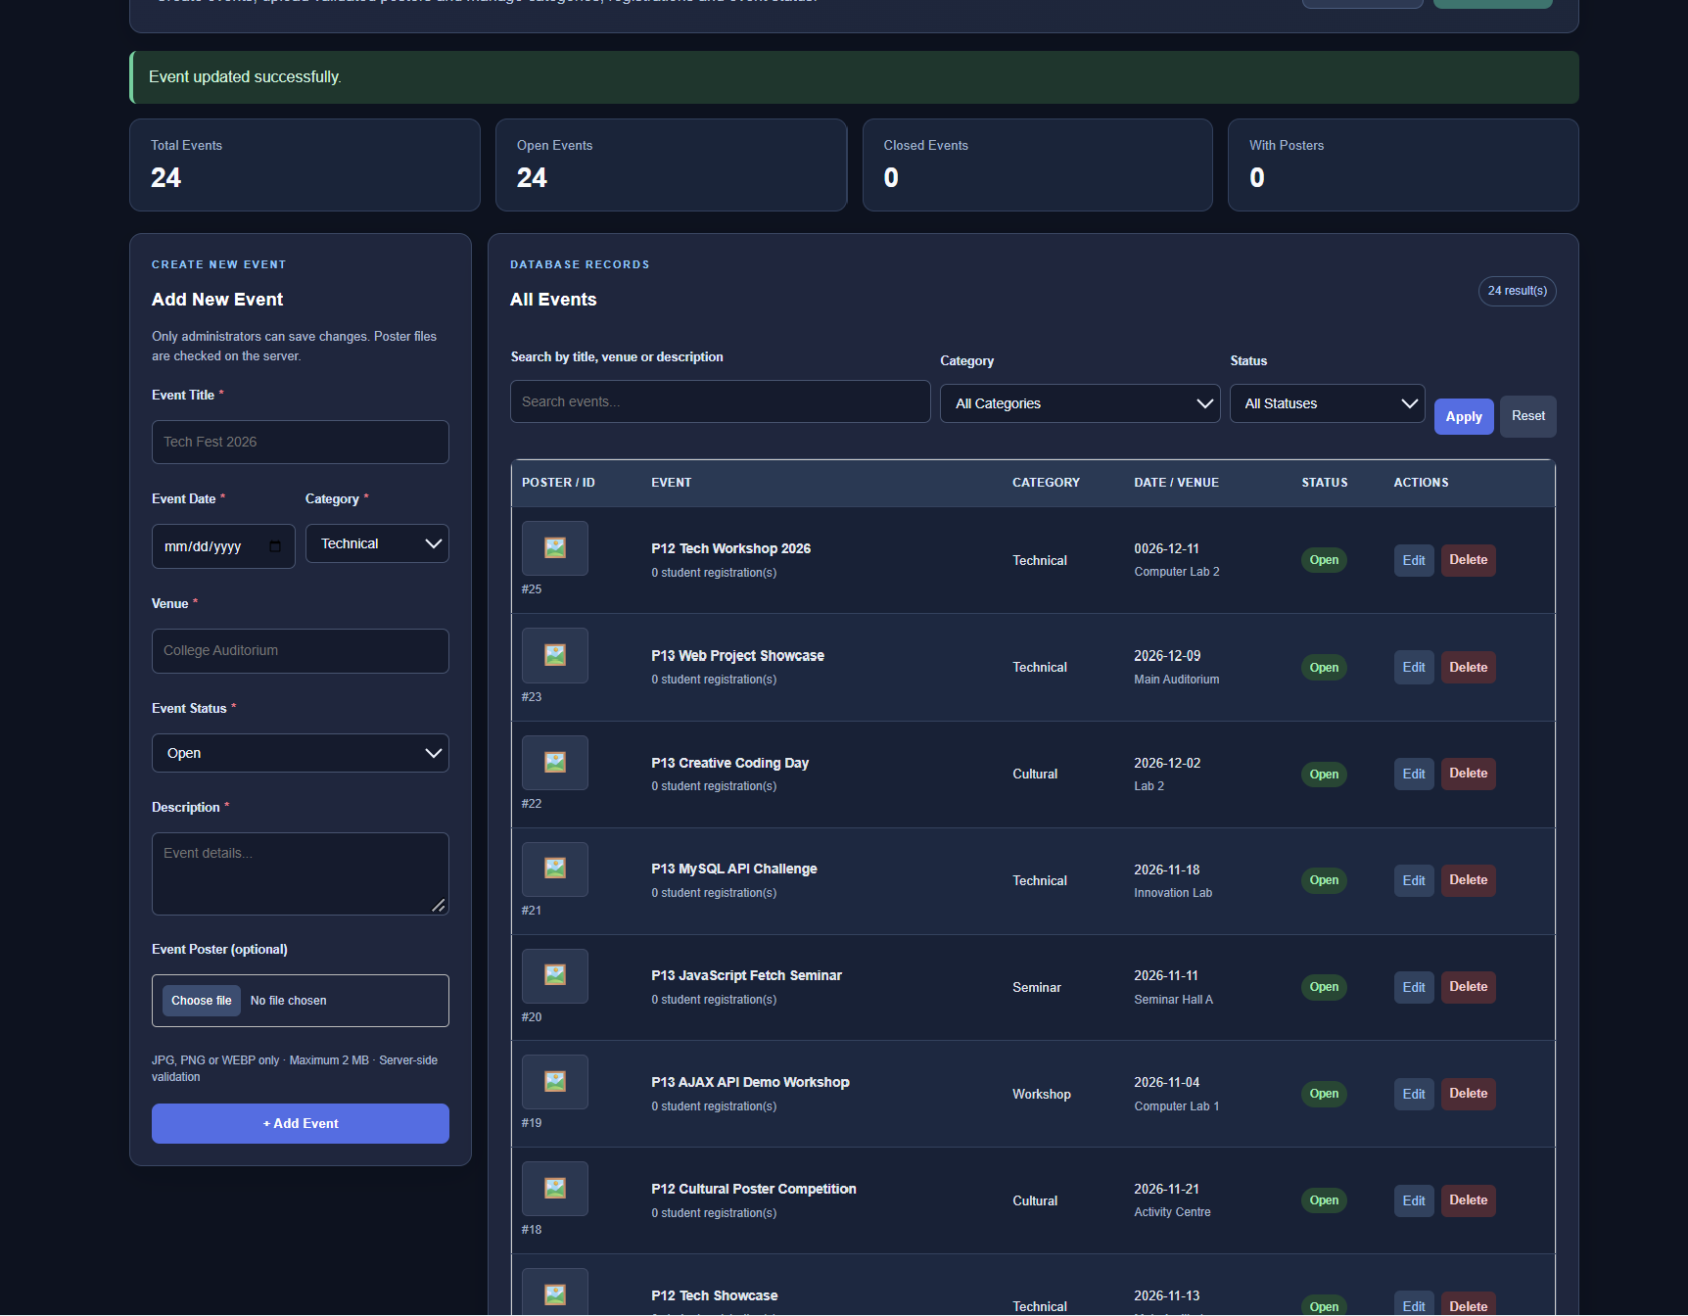
Figure 4: Event Update Confirmation in the CRUD Interface

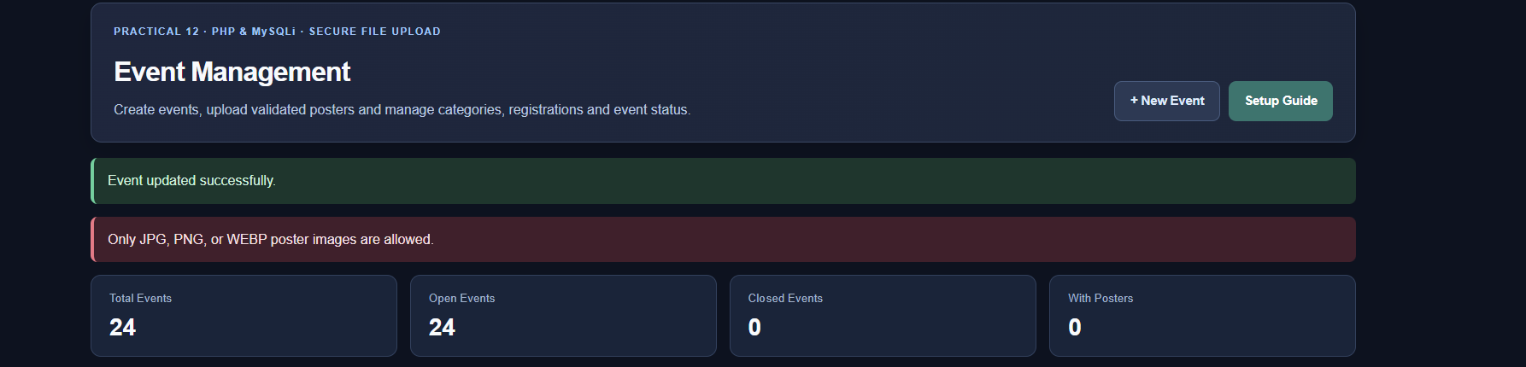
Figure 5: Unsupported TXT Poster Rejected with Validation Error
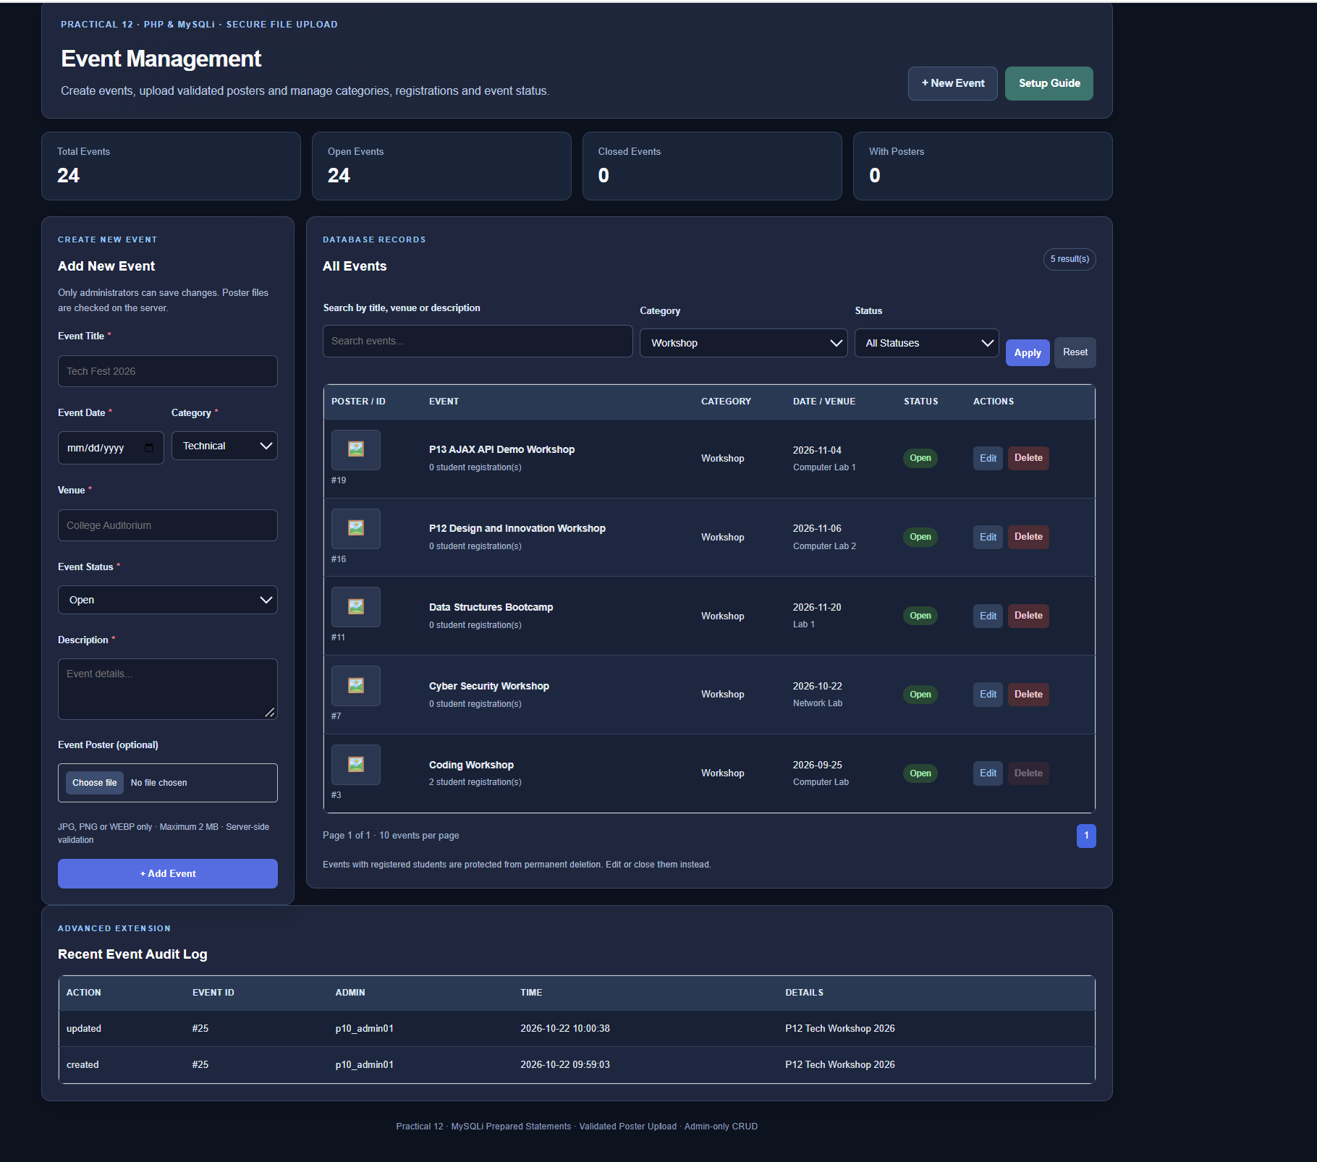
Figure 6: Workshop Category Filter and Recent Event Audit Log

A. GitHub Repository Link:
https://github.com/adrojatarang8-art/StudentHub
B. Challenges Faced:
• I corrected the Practical 12 folder structure so login.php and event_management.php could be opened directly from localhost/practical12/.
• I fixed the event-management header colors to match the dark theme and make the title readable.
• After creating the test event, the list displayed an incorrect year (0026) and no saved poster; a later correction and poster upload were reported but were not photographed.
• I tested validation using a .txt file, which the application correctly rejected with a clear error message.
• I used category filtering and the Recent Event Audit Log to inspect event records and recorded create/update actions.
C. Learning Outcome:-
I learned to build and test an administrator-only PHP/MySQLi event-management module for adding, viewing, updating and deleting events; selecting categories and open/closed status; uploading posters with allowed-format validation; and showing success/error feedback. I also learned to verify database-driven pages, filters and event audit entries while documenting gaps in screenshot evidence.
Faculty Remarks:

